Packing Labels Documentation

# Interface

This is the current interface, which may not be as user friendly as I would like. It may have changed prior to me updating this document. However, principals and the functionality should remain the same.

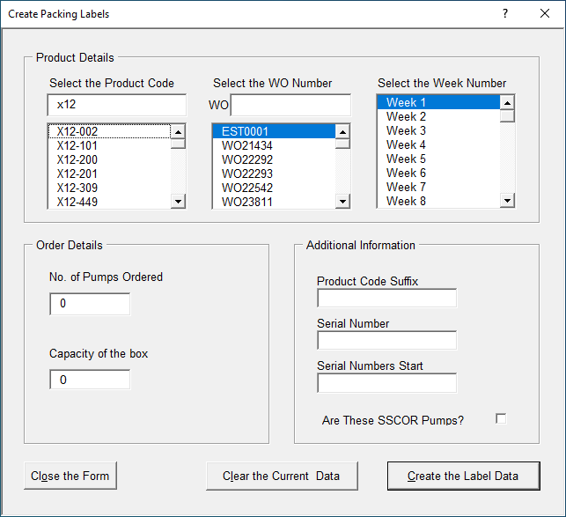

## Product Details

The text box immediately under Select the Product Code is a search facility where you may enter the first two or three characters of the Product number to reduce the number of options in the list below it. The Product Code you select will appear on the labels.

As you will see in the image above x12 has been entered and only those parts the begin x12 are showing in the list below. The greater number of characters you enter the fewer number of items will remain in the list.

### Select the WO Number

The text box immediately under Select the WO Number is a search facility where you may enter the first two or three characters of the Works Order Number to reduce the number of options in the list below it. The Works Order Number you select will appear on the labels.

The greater number of characters you enter the fewer number of items will remain in the list.

### Select the Week Number

Select the number of the week that you want on the labels.

## Order Details

### No. of Pumps Ordered

This is where you will enter the number of pumps you are shipping. It may not be the same as the number of pumps on the works order.

### Capacity of the box

This is where you will enter the number of pumps that will fit in to a box.

## Additional Information

### Product Code Suffix

If you need some additional text or numbers added to the end of the Product Code, as it will appear on the labels, then enter it here. If you don’t, leave the box empty.

### Serial Number Suffix

If you need some additional text or numbers added to the end of the Serial Number, as it will appear on the labels, then enter it here. If you don’t, leave the box empty.

### Serial Numbers Start

If you are finishing a partly completed order and want the serial number to start at a number greater than 1, enter the first serial number here.

### Are These SSCOR Pumps?

If the pumps are for a SSCOR order, the parts of the serial number are in a completely different order, so it they are click this box to add a tick to it.

## Buttons

I hope that these are self-explanatory.

### Close the Form

This closes the form.

### Clear the Current Data

This will reset the data to the defaults. It enables you to start again if you make a mistake.

### Create the Label Data

Once you are happy that the data you have entered is correct, click this button to generate the data that will be printed on the labels.

# Usage

# Change Requests

2018-01-04 Michail asked for a search facility on the Works Orders and Product Codes.

2017-11-22 FIX - Off by one error in the last serial number on the first label.

2017-11-09 Raff has asked for a way to start the serial number from any number he chooses.

2017-01-20 David Gibb has asked that the script be changed to accommodate the selection of the year. This is due to labels from Welwyn Garden City having last year (2016) in the serial number and David needs to match this on the packing labels.